Mobile Payments go Viral:
M-PESA in Kenya
Ignacio Mas and Dan Radcliffe, Bill & Melinda Gates Foundation
March 2010

Abstract

M-PESA is a small-value electronic payment and store of value system that is accessible from ordinary mobile phones. It has seen exceptional growth since its introduction by mobile phone operator Safaricom in Kenya in March 2007: it has already been adopted by 9 million customers (corresponding to 40% of Kenya’s adult population) and processes more transactions domestically than Western Union does globally. M-PESA’s market success can be interpreted as the interplay of three sets of factors: (i) pre-existing country conditions that made Kenya a conducive environment for a successful mobile money deployment; (ii) a clever service design that facilitated rapid adoption and early capturing of network effects; and (iii) a business execution strategy that helped M-PESA rapidly reach a critical mass of customers, thereby avoiding the adverse chicken-and-egg (two-sided market) problems that afflict new payment systems.

M-PESA in a Nutshell
M-PESA was developed by mobile phone operator Vodafone and launched commercially by its Kenyan affiliate Safaricom in March 2007. M-PESA (“M” for mobile and “PESA” for money in Swahili) is an electronic payment and store of value system that is accessible through mobile phones. To access the service, customers must first register at an authorized M-PESA retail outlet. They are then assigned an individual electronic money account that is linked to their phone number and accessible through a SIM card-resident application on the mobile phone. Customers can deposit and withdraw cash to/from their accounts by exchanging cash for electronic value at a network of retail stores (often referred to as agents). These stores are paid a fee by Safaricom each time they exchange these two forms of liquidity on behalf of customers. Once customers have money in their accounts, they can use their phones to transfer funds to other M-PESA users and even to non-registered users, pay bills, and purchase mobile airtime credit. All transactions are authorized and recorded in real time using secure SMS, and are capped at $500.
Customer registration and deposits are free. Customers then pay a flat fee of around US 40¢ for person-to-person (P2P) transfers and bill payments, US 33¢ for withdrawals (for transactions less than US $33), and US 1.3¢ for balance inquiries. Individual customer accounts are maintained in a server that is owned and managed by Vodafone, but Safaricom deposits the full value of its customers’ balances on the system in pooled accounts in two regulated banks. Thus, Safaricom issues and manages the M-PESA accounts, but the value in the accounts is fully backed by highly liquid deposits at commercial banks. Customers are not paid interest on the balance in their M-PESA accounts. Instead, the foregone interest is paid into a not-for-profit trust fund controlled by Safaricom (the purpose of these funds has not yet been decided).
M-PESA is useful as a retail payment platform because it has extensive reach into large segments of the population. Exhibit 1 shows the size of various retail channels in Kenya. Note that there are nearly five times the number of M-PESA outlets than the total number of PostBank branches, post offices, bank branches, and automated teller machines (ATMs) in the country. Using existing retail stores as M-PESA cash-in/cash-out outlets reduces deployment costs and provides greater convenience and lower cost of access to users.
Exhibit 1: Outlets offering financial services in Kenya

A Snapshot of M-PESA after Three Years
M-PESA is going from strength to strength. As shown in Exhibit 2, Safaricom reached the 9 million customer mark in under three years.
Exhibit 2: Growth of M-PESA Customer Base
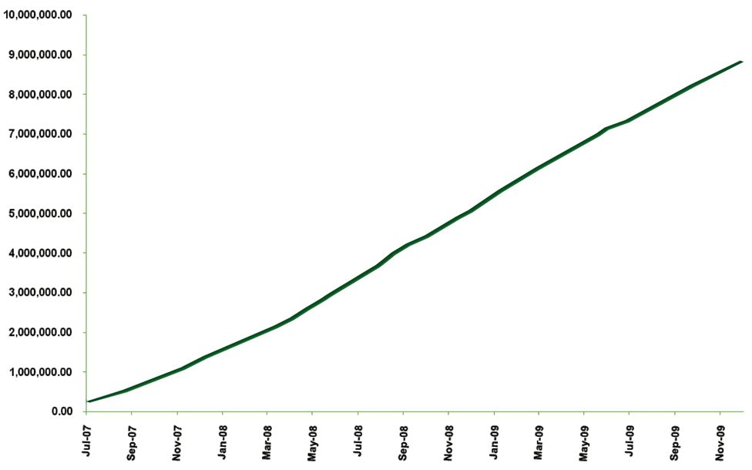
The latest developments and figures reported by Safaricom as of January 2010 are:
- 9.0 million registered customers, of which the majority are active. This corresponds to 60% of Safaricom’s customer base, 23% of the entire population, and 40% Kenyan adults.
- 16,900 retail stores at which M-PESA users can cash-in and cash-out, of which nearly half are located outside urban centers.
- US $320 million per month in person-to-person (P2P) transfers. On an annualized basis, this is equal to roughly 10% of Kenyan gross domestic product (GDP). Although transactions per customer have been on a rising trend, they remain quite low, probably still under two P2P transactions per month.
- US $650 million per month in cash deposits and withdrawal transactions at M-PESA stores. The average transaction size is around US $33, but Vodafone has stated that half the transactions are for a value of less than US $10.
- US $7 million in monthly revenue (based on the six months to September 2009). This is equal to 8% of Safaricom revenues.
- 19% of Safaricom airtime purchases are conducted through M-PESA.
- There are 27 companies using M-PESA for bulk distribution of payments. Safaricom itself used it to distribute dividends on Safaricom stock to 180,000 individual shareholders who opted to receive their dividends into their M-PESA accounts, out of a total of 700,000 shareholders.
- Since the launch of the bill pay function in March 2009, there are 75 companies using M-PESA to collect payments from their customers. The biggest user is the electric utility company, which now has roughly 20% of their one million customers paying through M-PESA.
- At least two banks (Family Bank and Kenya Commercial Bank) are using M-PESA as a mechanism for customers to either repay loans or withdraw funds from their banks accounts.

Customer Perspectives on M-PESA
A survey of 3,000 M-PESA users and non-users conducted in the fall of 2008 shed considerable light on the profile of M-PESA’s early adopters and customer usage patterns. The survey found that the average M-PESA user is, in comparison to non-users, twice as likely to have a bank account (72 percent versus 36 percent), wealthier (65 percent higher expenditure levels), more literate, and better educated. Early adopters appear to be experienced with banking propositions and fairly “tech savvy,” which probably makes them more acutely aware of the convenience offered by M-PESA relative to the alternatives.
Exhibit 3 highlights how customers use the service. Consistent with its broad market positioning, more than half the sample use it primarily for sending and receiving money. Interestingly, 21 percent of M-PESA users report using M-PESA for storing money. However, the survey revealed that less than 1 percent of accounts had balances of over KSh 1,000 (US $13), and a government audit of M-PESA in August 2009 revealed that the average balance on M-PESA accounts was only US $2.70. The survey also found that 52 percent of customers use the service on a monthly basis, suggesting that customers have yet to incorporate M-PESA into their daily lives.
Exhibit 3: The Uses of M-PESA
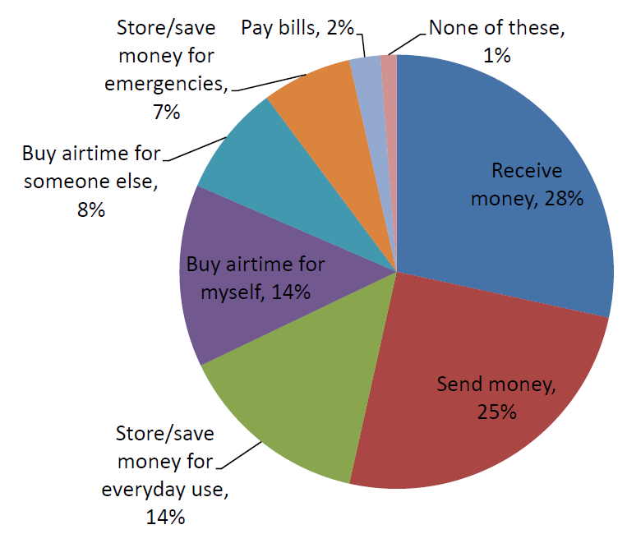
The survey also found that 98 percent of users report being happy with the service and 84 percent claim that losing M-PESA would have a large, negative effect on them. Exhibit 4 below illustrates how customers compare M-PESA with alternative services.
Exhibit 4: Comparing M-PESA with the Alternatives
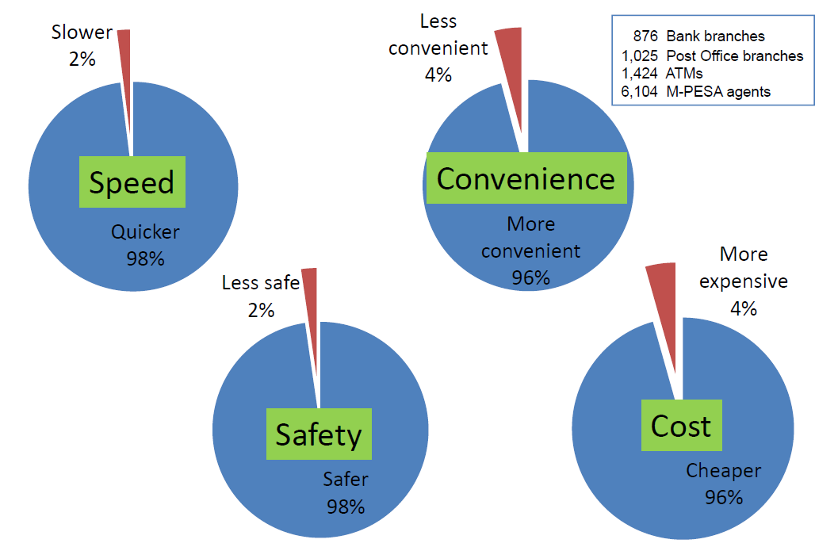

M-PESA’s Service Evolution
M-PESA’s original core offering was the P2P payment – enabling customers to send money to anyone with access to a mobile phone. It opened up a market for transactions which previously were handled largely informally – through personal trips, friends, and public transport networks. That is represented by the set of transactions labeled ‘personal networks’ in the middle of Exhibit 5 below. Many P2P transactions can be characterized as scheduled payments (such as sending a portion of salary earned at the end of the month to relatives back home), but many represent a basic form of finance, where people can draw on a much broader network of family members, friends, and business associates to access money as and when required. Thus, M-PESA not only introduces a large measure of convenience to transactions that were already occurring, but it also enables a basic form of financial protection for a large number of users by enabling a network for instant, ‘on demand’ payments.
In recent months, Safaricom has increasingly opened up M-PESA to institutional payments – enabling companies to pay salaries and collect bill payments. In future, Safaricom envisions increased use of M-PESA for in-store purchases. Thus, Safaricom intends for M-PESA to become a more pervasive retail payments platform, a strategy represented by the downward arrow in Exhibit 5.

Exhibit 5: Potential Range of Transactions Supported by M-PESA

The challenge remains for M-PESA to become a vehicle for delivery of a broader range of financial services to the bulk of the Kenyan population – represented by the upward arrow in Exhibit 5. So far, the evidence is limited that people are willing to use the basic M-PESA account itself as a store of value. There is likely to be a need to develop more targeted savings products that balance customers’ preference for liquidity and commitment, and which connect into a broader range of financial institutions. This is the journey M-PESA must be on for it to deliver on its promise of addressing the challenge of financial inclusion in Kenya. A key precondition is regulation: the Central Bank of Kenya is in the process of finalizing regulations that will allow non-bank outlets and platforms such as M-PESA as a channel for formal deposit-taking. Beyond that, Safaricom will need to develop appropriate service, commercial and technical models for M-PESA to interwork with the systems of other financial service providers. We return to this topic in the concluding section of this paper.

The broader significance of M-PESA
Before examining why M-PESA achieved such dramatic growth, we discuss briefly three top-line lessons that have emerged from M-PESA’s success:
First, M-PESA has demonstrated the promise of leveraging mobile technology to extend financial services to large segments of unbanked poor people. This is fundamentally because the mobile phone is quickly becoming a ubiquitously deployed technology, even among poor segments of the population. Mobile penetration in Africa has increased from 3 percent in 2002 to 48 percent today, and is expected to reach 72 percent by 2014. And, happily, the mobile device mimics some of the key ingredients needed to offer banking services. The SIM card inside GSM phones can be used to authenticate users, thereby avoiding the costly exercise of distributing separate bank cards to low-profitability poor customers. The mobile phone can also be used as a point of sale (POS) terminal to initiate financial transactions and securely communicate with the appropriate server to request transaction authorization, thus obviating the need to deploy costly dedicated devices in retail environments.
Second, M-PESA has demonstrated the importance of designing usage- rather than float-based revenue models for reaching poor customers with financial services. Because banks make most of their money by collecting and reinvesting deposits, they tend to distinguish between profitable and unprofitable customers based on the likely size of their account balances and their ability to absorb credit. Banks thus find it difficult to serve poor customers because the revenue from reinvesting small-value deposits is unlikely to offset the cost of serving these customers. In contrast, mobile operators in developing countries have developed a usage-based revenue model, selling prepaid airtime to poor customers in small increments, such that each transaction is profitable on a stand-alone basis. This is the magic behind the rapid penetration of prepaid airtime into low-income markets: a card bought is profit booked, regardless of who bought the prepaid card. This usage-based revenue model is directly aligned with the model needed to sustainably offer small-value cash-in/cash-out transactions at retail outlets and would make possible a true mass-market approach, with no incentive for providers to deny service based on minimum balances or intensity of use.
Third, M-PESA has demonstrated the importance of building a low-cost transactional platform which enables customers to meet a broad range of their payment needs. Once a customer is connected to an e-payment system, she can use this capability to store money in a savings account, send and receive money from friends and family, pay bills and monthly insurance premiums, receive pension or social welfare payments, or receive loan disbursements and repay them electronically. In short, when a customer is connected to an e-payment system, her range of financial possibilities expands dramatically.
Putting these elements together, M-PESA has prompted a rethink on the optimal sequencing of financial inclusion strategies. Where most financial inclusion models have employed “credit-led” or “savings-led” approaches, the M-PESA experience suggests that there may be a third approach – focus first on building the payment “rails” on which a broader set of financial services can ride.

Accounting for M-PESA’s Success: Three Perspectives
The rest of this paper explores M-PESA’s success from three angles. First, we examine the environmental factors in Kenya that set the scene for a successful mobile money development. Then, we examine the service design features that facilitated the rapid adoption and frequent use of M-PESA. And, finally, we examine the elements in Safaricom’s execution strategy that helped M-PESA rapidly reach a critical mass of customers.
In so doing, we draw extensively on a sequence of four papers which readers can refer to for more detailed accounts of the M-PESA story: Heyer and Mas (2009) on the country factors that led to M-PESA’s success, Mas and Morawczynski (2009) on M-PESA’s service features, Mas and Ng’weno (2010) on Safaricom’s execution, and Mas (2009) on the economics underpinning branchless banking systems.
Beyond the compelling marketing, cold business logic and consistent execution of M-PESA, its success is a vivid example of how great things happen when a group of leaders from different organizations rally around common challenges and ideas. The story of M-PESA straddles the social and the commercial, the public and the private, powerful organizations and determined individuals:
The Individuals and Institutions Behind M-PESA
The idea of M-PESA was originally conceived by a London-based team within Vodafone, led by Nick Hughes and Susie Lonie. This team believed the mobile phone could play a central role in lowering the cost of poor people to access financial services. The idea was seized by the Safaricom team in Kenya, led by CEO Michael Joseph and Product Manager Pauline Vaughn. They toyed with the idea, convinced themselves of its power, developed it thoroughly prior to the national launch, and oversaw a very focused execution.
The Central Bank of Kenya (CBK), and in particular its Payments System group led by Gerald Nyoma, deserves much credit for being open to the idea of letting a mobile operator take the lead in providing payment services to the bulk of the population. The CBK had recently been made aware of the very low levels of bank penetration in the country by the first FinAccess survey in 2006, and they were determined to explore all reasonable options for correcting the access imbalance. The CBK worked in close partnership with Vodafone and Safaricom to assess the opportunities and risks involved prior to the launch and as the system developed. They were conscious that premature regulation might stifle innovation, so they chose to monitor closely and learn – and formalize the regulations later.
Finally, the UK’s Department for International Development (DfID) played an instrumental role, first by funding the organizations that made the FinAccess survey possible —the Financial Sector Deepening Trust in Kenya, the FinMark Trust in South Africa—, and then by providing seed funding to Vodafone to trial its earliest experiments with M-PESA. DfID’s role in spotlighting the need for mobile payments and funding the early risk demonstrates good roles for donor funding.

- Kenya Country Factors: Unmet Needs, Favorable Market Conditions
The growth of M-PESA is a testament to Safaricom’s vision and execution capacity. However, Safaricom also benefited from launching the service in a country which contained several enabling conditions for a successful mobile money deployment, including: strong latent demand for domestic remittances, poor quality of available financial services, a banking regulator which permitted Safaricom to experiment with different business models and distribution channels, and a mobile communications market characterized by Safaricom’s dominant market position and low commissions on airtime sales.

Strong Latent Demand for Domestic Remittances
Safaricom based the initial launch of the M-PESA service on the ‘send money home’ proposition, even though it also allows the user to buy and send airtime, store value and, more recently, to pay bills. Demand for domestic remittance services will be larger where migration results in splitting of families, with the bread-winner heading to urban centers and the rest of the family staying back home. This is the case in Kenya, where 17 percent of households depend on remittances as their primary income source.

In her study of M-PESA, Ratan (2008) suggests that the latent demand for domestic remittances is related to urbanization ratios. More propitious markets will be those where the process of rural-urban migration is sufficiently rooted to produce large migration flows, but not so advanced that rural communities are hollowed out. Countries with mid-range urbanization ratios (20 percent to 40 percent), especially those that are urbanizing at a rapid rate, are likely to exhibit strong rural-urban ties requiring transfer of value between them. This is the case in many African countries like Kenya and Tanzania, where the urbanization ratios are 22 percent and 25 percent, respectively. In the Philippines and Latin America, where urbanization ratios exceed 50 percent, remittances are more likely to be triggered by international rather than domestic migration patterns.

Where entire nuclear families move, remittances will be stronger where there is cultural pressure to retain connection with one’s ancestral village. In Kenya, migrants’ ties with rural homes are reinforced by an ethnic (rather than national) conception of citizenship. These links are expressed through burial, inheritance, cross-generational, social insurance and other ties, even in cases where migrants reside more or less permanently in cities. In other settings, a greater emphasis on national as opposed to local or ethnic identity may have diminished the significance of the rural ‘home’ and hence dampened domestic remittance flows.

Poor Quality of Existing Alternatives
Latent demand for e-payments must be looked at in the context of the accessibility and quality of the alternatives. If there are many good alternatives to mobile payments (as is typically the case in developed countries), it will be difficult to convince users to switch to the new service. In the Philippines, for example, the G-Cash and Smart Money mobile payment services experienced low take-up in part due to the availability of a competitive alternative to mobile payments – an extensive and efficient semi-formal retail network of pawnshops which offered domestic remittance services at 3 percent.

In Kenya, the most common channel for sending money before M-PESA was informal bus and matatu (shared taxi) companies. These companies are not licensed to transfer money, resulting in considerable risk that the money will not reach its final destination. And Kenya Post, Kenya’s major formal remittance provider, is perceived by customers as costly, slow, and prone to liquidity shortages at rural outlets. Meanwhile, Kenya’s sparse bank branch infrastructure (840 branches) is far too limited to compete with M-PESA’s 16,900 cash-in/cash-out outlets. Exhibit 6 below illustrates how Kenyan households sent money before and after M-PESA. Note the dramatic reduction in the use of informal bus systems and Kenya Post to transfer money between 2006 and 2009.

Exhibit 6: Money Transfer Behavior Before and After M-PESA
As noted above, M-PESA’s early adopters were primarily banked customers, which suggests that M-PESA did not acquire its initial critical mass through competition with the formal sector but rather as a complement to formal services for clients who were wealthier, more exposed to formal financial service options, and less risk-averse. As services move deeper into the market, unbanked users will likely drive M-PESA’s expansion, due to the competitive advantages of formal mobile offers over other options. This is one reason why Africa, with its high population of unbanked, is seen as such a promising market for mobile money deployments.

A Supportive Banking Regulator
Regulation of mobile money can help to secure trust in new mobile money schemes. At the same time, regulation may constrain the success of a mobile money deployment by limiting the scheme operator’s degrees of freedom in structuring the business model, service proposition, and distribution channels. In the case of M-PESA, Safaricom had a good working relationship with the Central Bank of Kenya (CBK) and was given regulatory space to design M-PESA in a manner that fit its market.

The CBK and Safaricom worked out a model that provided sufficient prudential comfort to the CBK. The CBK insisted that all customer funds be deposited in a regulated financial institution, and reviewed the security features of the technology platform. In turn, the CBK allowed Safaricom to operate M-PESA as a payments system, outside the provisions of the banking law.

Safaricom has had to pay a certain price for this arrangement. For instance, interest earned on deposited balances must go to a not-for-profit trust and cannot be appropriated by Safaricom or passed on to customers. There are also limits on transaction sizes to address anti-money laundering concerns. But, fundamentally, Safaricom was able to design the service as it saw fit, without having to contort its business model to fit within a prescribed regulatory model.

The CBK has continued to support M-PESA’s development, even in the face of pressure from banks. In late 2008, after a lobbying attack from the banking industry seeking to shut down the service, the Central Bank did an audit of the M-PESA service at the request of the Ministry of Finance and declared it safe and in line with the country’s objectives for financial inclusion. So far, the Central Bank appears justified in its confidence in M-PESA as there have been no major reports of fraud. And system downtime, although frequent, has not been catastrophic.

A Dominant Mobile Operator and Low Airtime Commissions
The chances of a mobile money scheme taking root depend also on the strength of the mobile operator within its market. Market share is an important asset because it is associated with a larger customer base for cross-selling the mobile money service, a larger network of airtime resellers which can be converted into cash-in/cash-out agents, stronger brand recognition and trust among potential customers, and larger budgets to finance the heavy up-front market investment needed to scale a deployment. With a market share of around 80 percent, Safaricom enjoyed each of these benefits when it launched M-PESA.
A mobile money deployment will also have greater chance of success in countries where the commissions mobile operators pay airtime resellers are relatively low. This is because if commissions are too high, resellers will not be attracted by the lower commissions of the incipient cash-in/cash-out business. In Safaricom’s case, airtime commissions total 6 percent, of which 5 percent are passed on to the retail store. A 1-2 percent commission on a cash-in/out transaction is plausibly attractive – the store need only believe that the cash business may be five times as big as the airtime business in volume terms. This seems reasonable, considering that the bulk of airtime sales are of low denominations (around US 25¢).

A Reasonable Base of Banking Infrastructure
Finally, the ability of M-PESA stores to convert cash to e-value for customers depends on how easily they can rebalance their liquidity portfolios. This will be more difficult to achieve if bank branch penetration is too low, as this will force the agent channel to develop alternative cash transport mechanisms. Thus, an agent network will need to rely on a minimal banking retail infrastructure. (This qualifies our earlier point that lack of access to formal services indicates a strong market opportunity. There appears to be a branch penetration “sweet spot” for mobile money, where penetration is not so high that it hampers demand for mobile money services, but not so low that agents are unable to manage their liquidity.) Kenya is reasonably well supplied with rural liquidity points due to the branch networks of Equity Bank and other banks and MFIs. Even so, shortage of cash or electronic value for M-PESA agents is a problem both in country and city. Other countries face more serious liquidity constraints, especially in rural areas, which is likely to be a major factor affecting the success of mobile services in specific country contexts.

- M-PESA’s Service Design: Getting People onto the System
While M-PESA’s explosive growth was fueled by certain country-specific enabling conditions, the success of such an innovative service hinged on the design of the service. Conducting financial transactions through a mobile phone is not an intuitive idea for many people, and walking to a corner shop to conduct deposits and withdrawals may not at first seem natural to many. To overcome this adoption barrier, Safaricom had to design M-PESA in a way that (i) helped people grasp immediately how they might benefit from the service, (ii) removed all barriers that might prevent people from experimenting with the service; and (iii) fostered trust in the retail outlets who would be tasked with promoting the service, registering customers, and facilitating cash-in/cash-out services.

A Simple Message Targeting a Big Pain Point
M-PESA was originally conceived as a way for customers to repay microloans. However, as Safaricom market-tested the mobile money proposition, they shifted the core proposition from loan repayment to helping people make P2P transfers to their friends and family. From its commercial launch, M-PESA has been marketed to the public with just three powerful words: “send money home.” This message was well adapted to the Kenyan phenomenon of split families discussed above and tapped into a major pain point for many Kenyans – the risks and high cost associated with sending money over long distances. This basic “e-remittance” product became the must-have “killer” application that continues to drive service take-up and remains the main (though not only) marketing message three years later. Although people have proved creative in using M-PESA for their own special needs, sending money home continues to be one of the most important uses – the number of households receiving money in Kenya has increased from 17 percent to 52 percent since M-PESA was introduced.

A Simple User Interface
The simplicity of M-PESA’s message has been matched by the simplicity of its user interface. The M-PESA user interface is driven by an application that runs from the user’s mobile phone. The service can be launched right from the phone’s main menu, making it easy for users to find. The menu loads quickly because it resides on the phone and does not need to be downloaded from the network each time it is called. The menu prompts the user to provide the necessary information, one prompt at a time. For instance, for a P2P transfer, the user will be asked to enter the destination phone number, the amount of the transfer, and the personal identification number (PIN) of the sender. Once all the information is gathered, it is fed back to the customer for final confirmation. Once the customer hits ‘OK,’ it is sent to the M-PESA server in a single text message. Consolidating all information into a single message reduces messaging costs, as well as the risk of the transaction request being interrupted half-way through. A final advantage is that the application can use the security keys in the user’s SIM card to encrypt messages end-to-end, from the user’s handset to Safaricom’s M-PESA server.

Removing Adoption Barriers: Free to Register, Free to Deposit, No Minimum Balances
Safaricom designed the scheme to make it as easy as possible for customers to try the new service. They designed a quick and simple process for customer registration, which can be done at any M-PESA retail outlet. Customers pay nothing to register and the clerk at the outlet does most of the work during the process. First, the clerk provides a paper registration form, where the customer enters his or her name, ID number (from Kenyan National ID, Passport, Military ID, Diplomatic ID or Alien ID), date of birth, occupation, and mobile phone number. The clerk then checks the ID and inputs the customer’s registration information into a special application in his mobile phone. If the customer’s SIM card is an old one that is not preloaded with the M-PESA application, the clerk replaces it. The customer’s phone number is not changed even if the SIM card is.
Safaricom then sends both the customer and outlet an SMS confirming the transaction. The SMS gives customers a four-digit start key (one-time password), which they use to activate their account. Customers enter the start key and ID number, and they are then asked to input a secret PIN of their choice, which completes the registration process. In addition to leading customers through this process, retail outlets explain how to use the application and the tariffs associated with each service. Such agent support early in the process is particularly important in rural areas, where a significant percentage of the potential user base is illiterate or unfamiliar with the functioning of their mobile phone.

While the minimum deposit amount is around US $1.25, there is no minimum balance requirement. Customers can deposit money for free, so there is no immediate barrier to taking up the service. M-PESA charges customers only for “doing something” with their money, such as making a transfer, withdrawal, or prepaid airtime purchase.

Being Able to Send Money to Anyone
M-PESA customers can send money to non M-PESA customers, including any person with a GSM mobile phone in Kenya, whether they are subscribers of Safaricom or of any of the other three competing networks (Zain, Orange and Yu). Under this service, money is debited from the sender’s account, and the recipient gets a code by SMS which it can use to claim the monetary value at any M-PESA store. Thus, it’s an account-to-cash service, with the receiver’s experience being similar to how Western Union works today. The pricing on this service is interesting: customers pay a higher (roughly triple) P2P charge when sending money to a non-customer, but at the other end cashing out is free for a non-customer, whereas registered customers pay a cash-out fee of at least US $0.30. So why “penalize” the customer rather than the non-customer? Safaricom understood that the sender had power over the recipient, so it chose to put pressure on the sender to require the recipient to register with M-PESA. Furthermore, the non-customer got a great first experience with M-PESA when he received money for free, which Safaricom hoped would convince them to register for M-PESA.

Building Trust in the Retail Network
Safaricom recognized that M-PESA would not achieve rapid adoption unless customers had enough trust in the M-PESA retail network that they were willing to conduct cash-in/cash-out transactions through those outlets. Safaricom employed several measures to build that trust.

First, it closely linked the M-PESA brand to customers’ affinity with and trust in Safaricom’s strong corporate brand. As the mobile operator in Kenya with a dominant share (over 80% at M-PESA’s launch and scarcely less today), Safaricom was already a broadly respected and trusted brand, even among low-income customers. As shown in Exhibit 7 below, M-PESA retail outlets are required to paint their store “Safaricom green” which not only builds gives customers confidence that the store is acting on behalf of Safaricom, but also makes it easier for customers to locate cash-in/cash-out points.

Exhibit 7: A Typical M-PESA Retail Outlet
Second, Safaricom ensured that customers can walk into any retail authorized outlet and have a remarkably similar experience. This has helped to build trust in the platform and the outlets, and gives customers a consistently positive view of the service. Safaricom maintains this control over the customer experience by investing heavily in store training and on-site supervision. Safaricom chose to centralize these functions in a single third-party vendor (Top Image) rather than relying on its channel intermediaries (e.g. master agents) to cascade these functions to retail shops. A Top Image representative visits each outlet at minimum on a monthly basis and rates each store on a variety of criteria, including visibility of branding and the tariff poster; availability of cash and M-PESA electronic value to accommodate customer transactions; and the quality of record-keeping.

Third, customers receive instant SMS confirmation of their transaction, helping customers learn by experience to trust the system. The confirming SMS constitutes an electronic receipt, which can be used in dispute resolution. The receipt confirming a money transfer details the name and number of the recipient and the amount transferred. This allows the sender to confirm instantly that the money was sent to the right person—the most common source of error.

Fourth, Safaricom requires its outlets to record all cash-in/cash-out transactions in a paper-based, Safaricom-branded logbook. For each transaction, the store clerk enters the M-PESA balance, the date, agent ID, transaction ID, transaction type (customer deposit or withdrawal), value, customer phone number, customer name, and the customer’s national ID number. Customers are then asked to sign the log for each transaction, which helps discourage fraud and also gives agents a way to offer first-line customer care for customers querying previous transactions. Each entry in the log is written in triplicate. The top copy is kept by the retail outlet for his own records, a second is passed on to the store’s master agent, and the third is sent to Safaricom. Recall that all information contained in the agent log (except for the customer signature) is captured electronically by Safaricom when the transaction is made and is available to the master agents via their web management system. Hence, the main purpose of the agent log is not for record-keeping, but to provide comfort to customers who are used to having transactions recorded on paper.

Simple and Transparent Pricing
M-PESA pricing is made transparent and predictable for users. There are no customer charges for the SMSs that deliver the service, and instead fees are applied to the actual customer-initiated transactions. All customer fees are subtracted from the customer’s account, and outlets cannot charge any direct fees. Thus, outlets collect their commissions from Safaricom (through their master agents) rather than from customers. This reduces the potential for agent abuses. Customer fees are uniform nationwide, and they are prominently posted in all outlet locations in the poster shown in Exhibit 8 (fees are in Kenyan Shillings (KSh), which trade at about 75 shillings to the US dollar).

M-PESA chose to specify its fees in fixed currency terms rather than as a percentage of the transaction. This makes it easier for customers to understand the precise cost of each transaction and helps them think of the fee in terms of the transaction’s absolute value (e.g., sending money to grandmother). It also helps them compare the transaction cost against alternative and usually costlier money-transfer arrangements (e.g., the matatu fare plus travel time).

Exhibit 8: M-PESA Tariff Structure
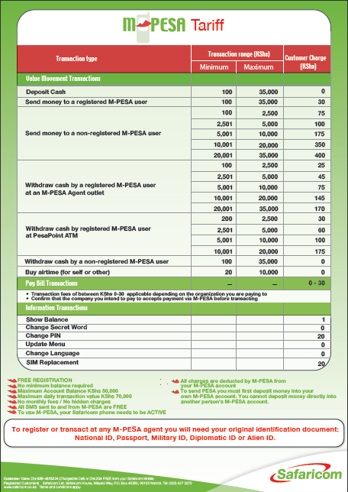
Deposits are free to customers. Withdrawals under US $33 cost around 0.33¢. Withdrawal charges are “banded” (i.e., larger transactions incur a larger cost) so as not to discourage smaller transactions. ATM withdrawals using M-PESA are slightly more expensive than at a retail outlet (40¢ versus 33.3¢).
P2P transfers cost a flat rate of around US 40¢. This is where Safaricom makes the bulk of its revenue. Thus, for a purely electronic transfer, customers pay more than double than what they pay for the average cash transaction (17¢) – despite the cost to provide being lower for purely electronic transactions than those involving cash. This reflects a notion of optimal pricing that is less based on cost and more on customer willingness to pay: enabling remote payments is the biggest customer pain point which M-PESA aims to address. M-PESA is cheaper than the other available mechanisms for making remote payments, such as money transfer by the bus companies, Kenya Post’s Postapay or Western Union.

It is noteworthy that M-PESA has maintained the same pricing for transactions in its first three years, despite the significant inflation experienced during the period. This has helped establish customer familiarity with the service. However, Safaricom has changed the pricing for two customer requests that do not involve a financial transaction: balance inquiries (because the initial low price generated an overly burdensome volume of requests) and PIN changes (because customers were far more likely to remember their PIN if the fee to change it was higher). The volume of both types of requests decreased substantially after these price changes. As noted earlier, the SMS confirmation of a transaction contains the available balance, which also helps cut down on the number of balance inquiries.

Liquidity of Last Resort at Bank Branches and ATMs
From very early on, M-PESA signed up banks as agents, so that any M-PESA customer could walk into the branches of several banks to conduct cash-in/cash-out transactions. One year after its launch, M-PESA went further and partnered with PesaPoint, one of the largest ATM service providers in Kenya. The PesaPoint network includes over 110 ATMs scattered all over the country, giving them a presence in all eight provinces. Customers can now retrieve money from any PesaPoint ATM. To do so, they must select “ATM withdrawal” from their M-PESA menu. They then receive a one-time ATM authorization code, which they enter on the ATM keyboard to make the withdrawal. No bank card is needed for this transaction. By accessing the PesaPoint ATM network, M-PESA customers can now make withdrawals at any time, day or night.

Yet M-PESA’s liquidity system is not without its challenges. Due to cash float constraints, M-PESA retail outlets cannot always meet requests for withdrawals, especially large withdrawals. Furthermore, the agent commission structure discourages outlets from handling large transactions. As a result, customers are sometimes forced to split their transactions over a few days, taking money out in bits rather than withdrawing a lump sum, adding both cost and inconvenience. It also undermines customer trust in M-PESA as a mechanism for high-balance, long-term saving. Using bank branches and ATMs to give customers a sort of liquidity mechanism of last resort bolstered the credibility of the M-PESA system.

- Execution: Getting to Critical Mass, Quickly
With a strong service design in place, Safaricom then set about developing its execution plan. It recognized that it would be difficult to scale M-PESA incrementally as it had to overcome three significant hurdles that are common to any new electronic payment system, namely:
- Adverse network effects: The value to the customer of a payment system depends on the number of people connected to and actively using it. The more people on the network, the more useful it becomes. While network effects can help a scheme gain momentum once it reaches a critical mass of customers, they can make it difficult to attract early adopters in the early phase when there are few users on it.
- Chicken-and-egg trap: In order to grow, M-PESA had to attract both customers and stores in tandem. It is hard to sell the proposition to customers while there are few stores to serve them, and equally hard to convince stores to sign up while there are few customers to be had. Thus, the scheme needed to drive both customer and store acquisition aggressively.
- Trust: Customers have to gain confidence in the reliability of a new system. In this case, customers had to be comfortable with three elements that were new at the time in Kenya: (i) a payment system that was operated by a mobile operator, (ii) going to non-bank retail outlets to meet their cash-in/cash-out needs, and (iii) accessing their account and initiating transactions through their mobile phone.
These problems reinforce each other in the early-stage development of a payments system, creating a significant hurdle to growth. We suspect this hurdle helps explain why many other mobile money deployments remain sub-scale. M-PESA overcame this hurdle through very forceful execution on two key fronts: (i) Safaricom made significant up-front investments in building a strong service brand for M-PESA; and (ii) Safaricom effectively leveraged its extensive network of airtime resellers to build a reliable, consistent retail network that served customers’ liquidity needs.

Aggressive Up-Front Investment in Promoting the M-PESA Brand
From the beginning, Safaricom sought to foster customer trust in the new payment mechanism and relied on existing customers to be the prime mechanism to draw in new customers. This was all the more difficult because Safaricom was introducing not only a new product, but an entirely new product category to a market that had little experience with formal financial services. The internal launch target for M-PESA was about 1 million customers within one year, equal to 17 percent of Safaricom’s customer base of about 6 million customers at that time.
National launch at scale. After small pilots involving less than 500 customers, M-PESA launched nationwide, increasing the likelihood that the service could reach a critical mass of customers in a short time frame. At launch, Safaricom had 750 stores and had made sure to cover all of Kenya’s 69 district headquarters. It was a massive logistical challenge that led to a great deal of customer and store confusion and, in the first months after launch, several days’ delays to reach customer service hotlines. User and store errors were frequent since everyone was new to the service. But the gamble paid off. Logistical problems subsided after a few months, leaving strong brand recognition and top-of-mind awareness among large segments of the population. The service outran first-year growth targets, quickly turning network effects in their favor as new customers begat more customers and turned M-PESA into a compelling business proposition for more stores.
An appropriate marketing mix. Initial marketing featured and targeted the wealthier city dweller with the need to “send money home” (see Exhibit 9a). This choice of the richer urban dweller as the initial customer created an aspirational image for M-PESA and avoided the impression that it was a low-value product aimed at the poor. Over time, the marketing moved from young, up-market urban dwellers with desk jobs to more ordinary Kenyans from lower-paid professions.
While M-PESA’s launch was associated with significant up-front investment in above-the-line marketing via TV and radio, there was also intense outreach through road shows and tents that traveled around the country signing people up, explaining the product, and demonstrating how to use it. Over time, as people became more familiar with the product and how to use it, it was no longer necessary to do this kind of hands-on outreach. TV and radio were largely replaced by the omnipresent M-PESA branding at all outlets, supported with a few large billboards. Newer ads (like the one in Exhibit 9b) feature a general emotional appeal, with a wider range of services indicated.
Exhibit 9a: Early M-PESA ad emphasizing sending money  from urban to rural areas linking into family and social ties   |   Exhibit 9b: Recent M-PESA ad with  more general emotional appeal

A Scalable Distribution Channel
Safaricom understood that the primary role of the mobile phone is to enable the creation of a retail outlet-based channel for cash-to-digital value conversion. And, for this cash-to-digital conversion to be broadly available to the bulk of the population, it had to develop a channel structure that could support thousands of M-PESA stores spread across a broad geography. To achieve this, Safaricom built four elements into its channel management execution strategy: (i) engaging intermediaries to help manage the individual stores, thereby reducing the number of direct contacts it had to deal with; (ii) ensuring that outlets were sufficiently incentivized to actively promote the service; (iii) maintaining tight control over the customer experience; and (iv) developing several different methods for stores to re-balance their stocks of cash and e-value.
Two-tier channel management structure. Safaricom created a two-tier structure with individual stores (sub-agents, in Safaricom’s parlance) who depended on master agents (referred to by Safaricom as Agent Head Offices [HO]). Agent HOs maintain all contact with Safaricom, and perform two key functions: (i) liquidity management (buying and selling M-PESA balance from Safaricom and making it available to individual stores under their responsibility), and (ii) distributing agent commissions (collecting the commission from Safaricom based on the overall performance of the stores under them and remunerating each store). Individual stores may be directly owned by an agent HO or may be working for one under contract.
Incentivizing stores. Retail outlets will not maintain sufficient stocks of cash and e-money unless they are adequately compensated for doing so. Hence, Safaricom pays commissions to agent HOs for each cash-in/cash-out transaction conducted by stores under their responsibility. Safaricom does not prescribe the commission split between agent HOs and stores, though most agent HOs pass on 70 percent of commissions to the store. For deposits under US $33, Safaricom pays US 13.3¢ in total commissions, of which US 7.4¢ goes to the store after tax. For withdrawals, Safaricom pays US 20¢ to the channel, of which US 11.1¢ goes to the store. So, assuming equal volumes of deposits and withdrawals, the store earns US 9.2¢ per transaction. Assuming the store conducts 60 transactions per day, it earns around US $5.50 – almost twice the prevailing daily wage for a clerk in Kenya.
Recall that Safaricom charges customers US 33.3¢ on a round-trip savings transaction (free deposit plus US 33.3¢ withdrawal), which is in fact equal to what the channel gets (US 13.3¢ on the deposit + US 20¢ on the withdrawal). So, assuming equal volumes of deposits and withdrawals, Safaricom doesn’t make any money on cash transactions. It merely “advances” commissions to the channel when customers deposit, and recoups it when customers withdraw. By charging US 40¢ on electronic P2P transactions (which are almost costless to provide), Safaricom opted to generate the bulk of its revenue from the service for which there is highest customer willingness to pay - remote P2P payments.
Because store revenues are dependent on the number of transactions they facilitate, Safaricom was careful not to flood the market with too many outlets, lest it depress the number of customers per agent. Instead, it maintained a balanced growth in the number of outlets relative to the number of active customers, resulting in an incentivized and committed agent base.
Maintaining tight control over the customer experience. Safaricom also recognized that customers need to have a good experience at the retail points, where the bulk of transactions take place. To ensure that it maintained control over the customer experience, Safaricom did not rely on the broad base of agent HOs to perform all channel management functions. Instead (as mentioned above), it concentrated the evaluation, training, and on-site supervision of stores in a single outsourcing partner, Top Image. Thus, we see that Safaricom delegated the more routine, desk-bound, non-customer-facing store support activities (e.g. liquidity management, distribution store commissions) to a larger pool of agent HOs. At the same time, through its contract with Top Image, it retained direct, centralized control over the key elements of the customer experience (e.g. store selection, training, supervision).
Developing multiple store liquidity management methods. By far the biggest challenge faced by M-PESA stores is maintaining enough liquidity in terms of both cash and e-float to be able to meet customer requests for cash-in and cash-out. If they take too many cash deposits, stores will find themselves running out of e-float with which to facilitate further deposits. If they do too many withdrawals, they will accumulate e-float but will run out of cash. Hence, they frequently have to rebalance their holdings of cash versus e-float. This is what we refer to as liquidity management.
The M-PESA channel management structure was conceived to offer stores three methods for managing liquidity. Two of these place the agent HO in a central role, with the expectation that the agent HO will ‘recycle’ e-float between locations experiencing net cash withdrawals (i.e. accumulating e-float) and locations with net cash deposits (i.e. accumulating cash). We discuss each of these methods in turn:

- Agent HO provides direct cash support to stores- Under this option, the store clerk comes to the agent HO’s head office to deliver or offload cash, or the agent HO sends cash runners to the store to perform these functions.
- Agent HO and stores use their respective bank accounts- Under this option, if the store has excess cash and wants to buy M-PESA e-float from the agent HO, the store will deposit the cash into the account of the agent HO at the nearest bank branch or ATM. Once the agent HO confirms receipt of the funds into its account, the HO transfers M-PESA e-float to the store’s M-PESA account. If the store wants to sell e-float to get cash, the store transfers M-PESA e-float to the agent HO. The agent HO then deposits (or transfers) money into the store’s account at the branch of the store’s bank. The store can then withdraw the cash at the nearest branch or ATM.
- Stores interact directly with a bank that has registered as an M-PESA “superagent”- Under this option, the agent HO does not get involved in liquidity management. Instead, stores open an account with a participating “superagent” bank. To rebalance their cash, stores deposit and withdraw cash against their bank account at the nearest branch or ATM of the bank. The store then electronically buys and sells e-float in real time against their bank account. From a store’s perspective, one drawback of the bank-based superagent mechanism is that it can only use it during banking business hours. This presents a problem for stores in the evenings and on weekends.

The e-float-cash nexus will remain the key constraint to the further development of M-PESA since it requires the physical movement of cash around the country and is thus the least scalable part of the system.

- M-PESA’s Future Evolution
The experience of M-PESA demonstrates how powerful a payment network that offers convenience at an affordable cost can be once a critical mass of customers is reached. It also shows that achieving critical mass requires both a service design that removes as many adoption barriers as possible and significant investment in marketing, branding, and agent network management. The Kenyan experience also suggests that several country-level environmental factors need to align to set the scene for a successful mobile money development, including the labor market profile (demand for remittances generated by rural-urban migration), the quality of available financial services, support from the banking regulator, and the structure of the mobile communications market (dominant mobile operator and low airtime commissions).

Yet, while M-PESA has been successful beyond what anyone could have imagined at its launch, the model still has substantial room to develop further. Our wish list for M-PESA is three-fold: (i) the mainstreaming of M-PESA’s regulatory treatment; (ii) pricing that opens up a much larger market of micro-transactions; and (iii) building of a much more robust ecosystem around M-PESA that enables customers to access a broader range of financial services. We address each of these below, before offering some concluding thoughts on how M-PESA offers a rekindled vision for achieving financial inclusion in developing countries.

Mainstreaming M-PESA’s Regulatory Treatment
M-PESA’s regulatory treatment as a payments vehicle needs to be formalized so that it can become regulated in the most appropriate way. To this end, the CBK has been trying to get a new payments law enacted by Parliament, but the draft has not yet been approved. The intention is for M-PESA to be covered in future by regulations emanating from this payments law. The CBK is also in the process of finalizing agent banking regulations which would allow commercial banks to use retail outlets as a delivery channel for financial services. Banks are quite reasonably complaining that they could not replicate the M-PESA service themselves since they are not currently allowed to undertake customer transactions through agent networks on their own. We believe there should be a level playing field, so that both banks and M-PESA can operate such agent networks.

Pricing that Enables Smaller Payments
M-PESA’s current pricing model is not conducive for small transactions. A US $10 P2P transfer plus withdrawal, for example, costs around 7 percent of the transaction size (US 0.40¢ for the transfer plus US 0.33¢ for the withdrawal). We see two advantages to adjusting M-PESA’s current pricing model to make it work for smaller-denomination transactions:
- It would make the service accessible to a poorer segment of the population, for whom pricing is now too high given their transactional needs. This would allow Safaricom to maintain customer growth once saturation starts to set in at current pricing.
- It would allow customers to use M-PESA for their daily transaction needs, and in particular to save on a daily basis when they are paid daily.

A reduction in customer prices could come about in several ways:
- For electronic transactions, the current P2P charge of US 40¢ allows for substantial scope for price reductions. But let’s be careful. There is a compelling logic behind the current model of extracting value from remote payments (for which there is substantial customer willingness to pay), while maintaining tight pricing on cash transactions (for which customers are less willing to pay). But we do believe there is room for ‘tranching’ the P2P fee so that the price works for smaller (e.g. daily) transactions.
- For cash transactions, one way to enable lower fees would be to create a category of street-level sub-agents, characterized by lower costs and commissions than store-based agents. Sub-agents would be a kind of “e-susu collector,” operating with small working capital balances in order to aggregate small customer transactions. Sub-agents would use normal M-PESA retail outlets to rebalance their cash and M-PESA stored value. The key principle here is that segmentation of customers needs to go hand-in-hand with segmentation of agents.

Linking with Banks and other Institutional Partners to Offer a Fuller Range of Financial Services
While some customers use M-PESA as a savings device, it still falls short of being a useful savings proposition for most poor people. According January 2009 CBK audit of M-PESA, the average balance on M-PESA accounts was around US $3. This is partly a “large number” problem: if 900,000 people used M-PESA to save, that would “only” be 10 percent of users and their savings would be diluted within an “average” savings balance. But the fundamental problem is that there is still a lot of conversion of electronic value back into cash, say following receipt of a domestic remittance. We attribute this to a combination of factors:

- Lack of marketing. Safaricom does not want to publicly promote the savings usage of M-PESA for fear of provoking the Central Bank into tighter regulation of M-PESA.
- Customer pricing. There is a flat fee of around US 33¢ for withdrawals under US $33, which means that small withdrawals carry a large percent fee.
- Product design. M-PESA works very much like an electronic checking account, and does not offer structured saving products which may help people build discipline around savings.
- Inflation. M-PESA does not pay interest. In an environment with 15 percent inflation (during its first full year of operation in 2008), this may be too onerous for savings.
- Trust. Deposits are not supervised by the Central Bank. And unlike payments, where trust can be validated experientially in real time, savings requires trust over a longer period of time.
- Privacy. People may want more privacy in their savings behavior than an agent provides.
- Excess liquidity. 16,000 cash-in points are also 16,000 cash-out points. The ubiquity of M-PESA agents may make it too easy for customers to cash-out their funds, thus limiting their ability to accumulate large balances.

Rather than expecting Safaricom to develop and market richer savings services, we believe that M-PESA should support savings propositions by linking into banks. M-PESA would then become a massive transaction acquisition network for banks rather than an alternative to them. Safaricom is beginning to connect with banks. In September 2009, for example, Family Bank connected to M-PESA to allow their customers to transfer money from M-PESA to their Family Bank account (using M-PESA’s bill pay function). This is following a successful pilot of loan repayments via M-PESA’s bill pay function.
M-PESA would also benefit from establishing further linkages with institutions beyond banks, such as billers, distributors, and employers. By promoting M-PESA as a mechanism for distributing salaries and social welfare payments, enabling payments across supply chains, and paying bills, the need for cash-in and cash-out would be minimized, and, as a result, a key component of transaction costs could be reduced. We also suspect savings balances would be higher if people received payments directly into their account rather than in cash, and if they had more useful things they could do with their money in electronic form.

Concluding thoughts: How M-PESA can reinvigorate visions around financial inclusion
Imagine a world where banks are nowhere near where you live. The nearest branch is 10 kilometers away, but it takes you almost an hour to get there by foot and bus because you don’t have your own wheels. With waiting times at the branch, that’s a round-trip of two hours – a quarter or so of your working day gone. And the bus fare is only 50 cents, but that’s one quarter of what you make on a good day. So each banking transaction costs you the equivalent of almost half a day’s wages. It would be like an ATM charging us something like $50 for each transaction, given what we earn.
Then, imagine a world without credit instruments or electronic payments. No checks, no cards, no money orders, no direct debits, no internet banking. All your transactions are done in cash or, worse, by bartering goods. All exchanges are physical, person-to-person, hand-to-hand. Consider the hassle and the risk of sending money to distant relatives, business partners, or banks.
How would you operate in such a world? A recent book, Portfolios of the Poor, has documented how poor people cope. How they save to ‘push’ some excess money from today to tomorrow, how they borrow to ‘pull’ tomorrow’s money to fund some needed expense today. You store some cash in the home to meet daily needs, you park it with a trusted friend for emergencies, you buy jewelry because that represents a future for your children, you pile up some bricks for the day when you can build an extra room in your house. You make regular contributions to a savings group with a circle of friends to build up a pot, and one day it will be your turn to take that pot home to buy new clothes. You also borrow from friends, seek advances from your employer, pawn some of your jewelry, and go to the moneylender.
The authors of Portfolios of the Poor document some poor families across India, Bangladesh and South Africa using up to 14 different mechanisms to manage their financial lives. They have few options, but you need to deploy all your ingenuity to use them all, precisely because none are very good. Some are not very safe because of their sheer physicality. If you save by storing your grain or buying goats, when your village hits hard times you may not be able to find ready buyers for your grain or goats. Forget about getting loans from neighbors during hard times. The local moneylender runs a quasi-monopoly in the village because it is too costly for you to go to other moneylenders in other villages, and in any case they don’t know you there. So you end up paying dearly for a loan.
We estimate that over 2 billion people need to cope with such circumstances. The lack of good financial options is undoubtedly one of the reasons why poor people are trapped in poverty. They cannot sustain or even aspire to higher income because they are not able to invest in better farming tools and seeds to enhance their productivity, start a microenterprise, or even take the time to search for better paying employment opportunities. Their income is volatile, often fluctuating daily, so without reliable ways of pushing and pulling money between good days and bad days they may have to face the stark decision to pull the kids out of school or put less food on the table during bad patches. And without good financial tools they may not be able to cope with shocks that set them back periodically. Most of these shocks are foreseeable if not entirely predictable: a drought, ill-health, lifecycle events such as marriage and death.
Cash is the main barrier to financial inclusion. As long as poor people can only exchange value in cash –or, worse, physical goods—they will remain too costly for formal financial institutions to address in significant numbers. Collecting low-value cash deposits and redeeming their savings back into small sums of cash requires a costly infrastructure which few banks are willing to make extensive in low-income or rural areas. But once poor people have access to cost-effective electronic means of payments such as M-PESA, they could, in principle, be profitably marketable subjects by a range of financial institutions.
M-PESA itself does not constitute financial inclusion. But it does give us glimpses of a commercially sound, affordable and effective way to offer financial services to all.

References
Camner, Gunnar and Emil Sjöblom (2009). Can the Success of M-PESA be repeated? A Review of Implementations in Kenya and Tanzania. Valuable Bits note, July.
Collins, Daryl, Morduch, Jonathan, Rutherford, Stuart, Ruthven, Orlanda (2009) Portfolios of the Poor: How the World’s Poor Live on $2 a Day, Princeton: Princeton University Press.
Davidson, Neil (2009). “Tactics for Tipping Markets: Influence Perceptions and Expectations,” GSM Association, Mobile Money for the Unbanked blog, November 15.
Financial Sector Deepening Trust [FSDT] (2009a). “FinAccess National Survey 2009: Dynamics of Kenya’s changing financial landscape,” June.
Financial Sector Deepening Trust [FSDT] (2009b). “Research on Mobile Payments Experience: M-PESA in Kenya.” Unpublished draft, December.
Financial Sector Deepening Trust [FSDT] (2007a). Finaccess Kenya 2006: Results of a Financial Survey on Access to Financial Services in Kenya.
Financial Sector Deepening Trust [FSDT] (2007a). Key findings of the FinScope survey in Tanzania in 2006.
GSM Association (2009). “Wireless Intelligence Database.” Available at www.wirelessintelligence.com.
Heyer, Amrik and Ignacio Mas (2009). “Seeking Fertile Grounds for Mobile Money.” Unpublished paper.
Hughes, Nick and Susie Lonie (2009). “M-PESA: Mobile Money for the Unbanked.” Innovations, special edition for the Mobile World Congress 2009 (Boston, MA: MIT Press).
Isaacs, Leon (2008), IAMTN presentation, MMTA conference Johannesburg, May.
Jack, Billy and Tavneet Suri (2009). “Mobile Money: the Economics of M-PESA.” Unpublished paper, October.
Juma, Victor (2009). “Family Bank offers new service linking accounts to M-PESA.” Business Daily,
18 December.
Kimenyi, Mwangi and Njuguna Ndung’u (2009). “Expanding the Financial Services Frontier: Lessons from Mobile Phone Banking in Kenya.” (Washington, DC: Brookings Institution), October.
Kinyanjui, Kui (2009). “Yu launches new mobile cash transfer platform.” Business Daily, 16 December.
Mas, Ignacio and Olga Morawczynski (2009). “Designing Mobile Money Services: Lessons from M-PESA.” Innovations, Vol. 4, Issue 2, Spring (Boston, MA: MIT Press).
Mas, Ignacio (2009). “The Economics of Branchless Banking” Innovations, Volume 4, Issue 2 (Boston, MA: MIT Press, Spring).
Mas, Ignacio and Amolo Ng’weno (2010). “Three keys to M-PESA’s success: Branding, channel management and pricing,” unpublished, January.
Mas, Ignacio (2008). M-PESA vs. G-Cash: Accounting for their Relative Success, and Key Lessons for other Countries. CGAP, unpublished, November.
Mas, Ignacio (2008). Realizing the Potential of Branchless Banking: Challenges Ahead, CGAP Focus Note 50 (Washington, DC: CGAP, October)
Mas, Ignacio and Sarah Rotman (2008). Going Cashless at the Point of Sale: Hits and Misses in Developed Countries, CGAP Focus Note 51 (Washington, DC: CGAP, December).
Morawczynski, Olga (2008). Surviving in the Dual System: How M-PESA is Fostering Urban-to-Rural Remittances in a Kenyan Slum. HCC8 Conference proceedings, Pretoria.
Morawczynski, Olga (2009). Exploring the usage and impact of transformational m-banking: The case of M-PESA in Kenya, mimeo.
Morawczynski, Olga & Mark Pickens (2009). Poor People Using Mobile Financial Services: Observations on Customer Usage and Impact from M-PESA. C-Gap Brief http://www.cgap.org/p/site/c/template.rc/1.9.36723/
Morawczynski, Olga and Gianluca Miscione (2008). “Examining trust in mobile banking transactions: The case of M-PESA in Kenya.” In: “Social Dimensions of Information and Communication Technology Policy: Proceedings of the 8th International Conference on Human Choice and Computers HCC8,” edited by C Avgerou, M Smith and P van den Besselaar, International Federation for Information Processing TC 9, Pretoria, South Africa, September 25-26, Volume 282 (Boston, MA: Springer), pp. 287–298.
Okoth, Jackson (2009). “Regulator gives M-PESA a clean bill of health.” The Standard, 27 January.
Okuttah, Mark (2009). “Safaricom changes method of recruiting M-pesa agents.” Business Daily, 23 December.
Ratan, A. L. (2008). Using Technology to Deliver Financial Services to Low-Income Households: A Preliminary Study of Equity Bank and M-PESA Customers in Kenya. Microsoft Research Technical Report, June.
Safaricom (2009). “M‐PESA Key Performance Statistics” and various financial reports available on www.safaricom.co.ke.
Suri, Tavneet and Billy Jack (2008). “The performance and Impact of M-PESA: Preliminary Evidence from a Household Survey.” Unpublished paper, June.

Ignacio Mas is Deputy Director and Dan Radcliffe Associate Program Officer in the Bill & Melinda Gates Foundation’s Financial Services for the Poor (FSP) team.
For more detailed accounts of the M-PESA service, see Hughes and Lonie (2009) for a historical account, Mas and Morawczynski (2009) for a fuller description of the service, and Mas and Ng’weno (2009) for the latest accomplishments of M-PESA.
The Subscriber Identification Module (SIM) card is a smart card found inside mobile phones that are based on the GSM family of protocols. The SIM card contains encryption keys, secures the user’s PIN on entry, and drives the phone’s menu. The Short Messaging Service (SMS) is a data messaging channel available on GSM phones.
We assume an exchange rate of US $1:75 Kenyan Schillings.
Kenya has a total population of nearly 40 million, with 78% living in rural areas and a GDP per capita of $1,600. 19% of adults have access to a formal bank account. See FSDT (2009a) for financial access data derived from the FinAccess survey, a nationally representative survey of 6,600 households conducted in early 2009.
Data from this table was pulled from the Central Bank of Kenya, Kenya Post Office Savings Bank, and Safaricom websites.
See www.safaricom.co.ke/fileadmin/template/main/images/MiscUploads/M-PESA%20Statistics.pdf for key monthly statistics for M-PESA. Additional figures are taken from Safaricom’s published half-year results for the period ending September 2009 and Central Bank of Kenya reports.
The 2009 FinAccess survey (FSDT [2009a], p. 16) confirmed that 40% of adults had used M-PESA.
The data and tables from this section are from Suri, Tavneet and William Jack (June 2008), “The performance and Impact of M-PESA: Preliminary Evidence from a Household Survey.” Unpublished Paper
Okoth, Jackson (2009). “Regulator gives M-PESA a clean bill of health.” The Standard, 27 January 2009.
Wireless Intelligence (www.wirelessintelligence.com)
FSD-Kenya (2006)
CIA World Fact Book (https://www.cia.gov/library/publications/the-world-factbook)
For fuller analyses of the use of mobile money for domestic remittances in Kenya, see Ratan (2008) and Morawczynski (2008).
FSD-Kenya (2006) and FSD-Kenya (2009).
The Central Bank of Kenya Act was amended in 2003 to give CBK broad oversight mandate over payment systems, but the operational modalities for its regulatory powers over payments systems have not been implemented, pending approval of a new National Payments System Bill which has languished in Parliament.
The results of the survey are explained in Okoth (2009).
FinAccess Survey, FSDT (2009a), p 16.
In her field research, Olga Morawczynski finds that sending KSh 1,000 through M-PESA is 27% cheaper than the post office’s PostaPay, and 68% cheaper than sending it via a bus company. See Morawczynski and Pickens (2009).
It has become habitual to illustrate network effects with reference to fax machines: the first set of people who bought a fax machine didn’t find it very useful as they couldn’t send faxes to many people. As more people bought fax machines, everyone’s faxes became more and more useful. Network effects are sometimes referred to as demand-side economies of scale, to emphasize that scale affects the value of the service to each customer. This distinguishes it from supply-side economies of scale, which refer to situations where average costs per customer fall as volume increases. Davidson (2009) discusses implications of network effects for mobile money.
Safaricom company results for the year ending March 2007.
The earliest pilot project conducted in 2004/05 revolved around microloan repayments, and involved the Commercial Bank of Africa, Vodafone, Faulu Kenya and MicroSave, in addition to Safaricom.
A survey of 1,210 users in late 2008 revealed that 70% of survey respondents claimed they had first heard about M-PESA from advertisements, TV or radio. FSDT (2009b), p. 6.
Safaricom wants the split to be 20%/80%, thus passing more of the commission down to the retail outlet.

